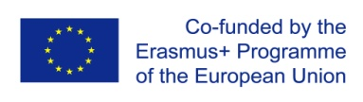


Logotype of the Sending Organization
Logotype of the Receiving Organization
Certificate
It is hereby declared that (1)_____________________________________, from (2)_________, born on (3)____/___/___, place of birth (4)_________________, successfully concluded the Unit of Learning Outcome (5)_____________________________________, code (6)______, EQF level (7)__, with (8)____ training hours, of the (9)_____________________ qualification, in the receiving organization (School/VET provider) (10)_____________________________________, located in (11)______________________ with the classification of (12.1)_______________ in the receiving country/organization, which corresponds to the classification of (12.2) _______________ in the sending country/organization, and to the Europass classification of (12.3) _______________, under the European Mobility Project number (13) _________________, in accordance with the Learning Agreement and the Memorandum of Understanding established with the sending organization (School/VET provider) (14) _____________________________________, which corresponds in the sending country/organization to (15) ________ ECVET Credit Points.

(16) Place, date  The Receiving Organization  _________________________________  (17) (Name of the Director and Stamp) | (16) Place, date  The Receiving Organization  _________________________________  (18) (Name of the Director and Stamp)

Insert the logotype of the Sending Organization
Insert the logotype of the Sending Organization

