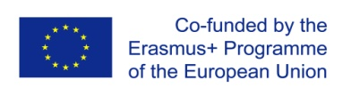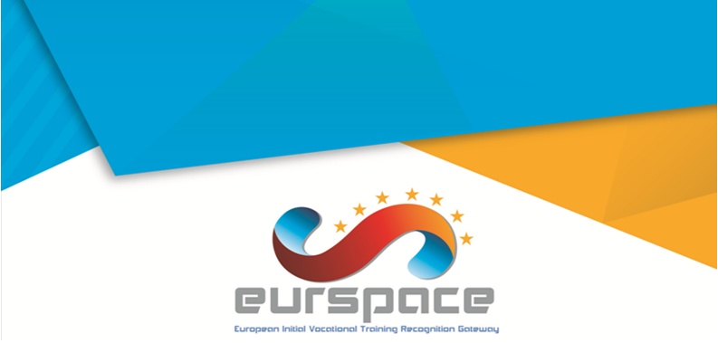

Logotype of the Sending Organization

Logotype of the Receiving Organization

**Certificate**

It is hereby declared that **(1)**_____________________________________, from **(2)**_________, born on **(3)**____/___/___, place of birth **(4)**_________________, successfully concluded the Unit of Learning Outcome **(5)**_____________________________________,code **(6)**______, EQF level **(7)**__, with **(8)**____ training hours, of the **(9)**_____________________ qualification, in the receiving organization (School/VET provider) **(10)**_____________________________________, located in **(11)**______________________ with the classification of **(12.1)**_______________ in the receiving country/organization, which corresponds to the classification of **(12.2)** _______________ in the sending country/organization, and to the *Europass* classification of **(12.3)** _______________, under the European Mobility Project number **(13)** _________________, in accordance with the Learning Agreement and the Memorandum of Understanding established with the sending organization (School/VET provider) **(14)** _____________________________________, which corresponds in the sending country/organization to **(15)** ________ ECVET Credit Points.

|  |  |
| --- | --- |
| **(16)** Place, date  The Receiving Organization  _________________________________  **(17)** (Name of the Director and Stamp) | **(16)** Place, date  The Receiving Organization  _________________________________  **(18)** (Name of the Director and Stamp) |

Insert the logotype of the Sending Organization

Insert the logotype of the Sending Organization